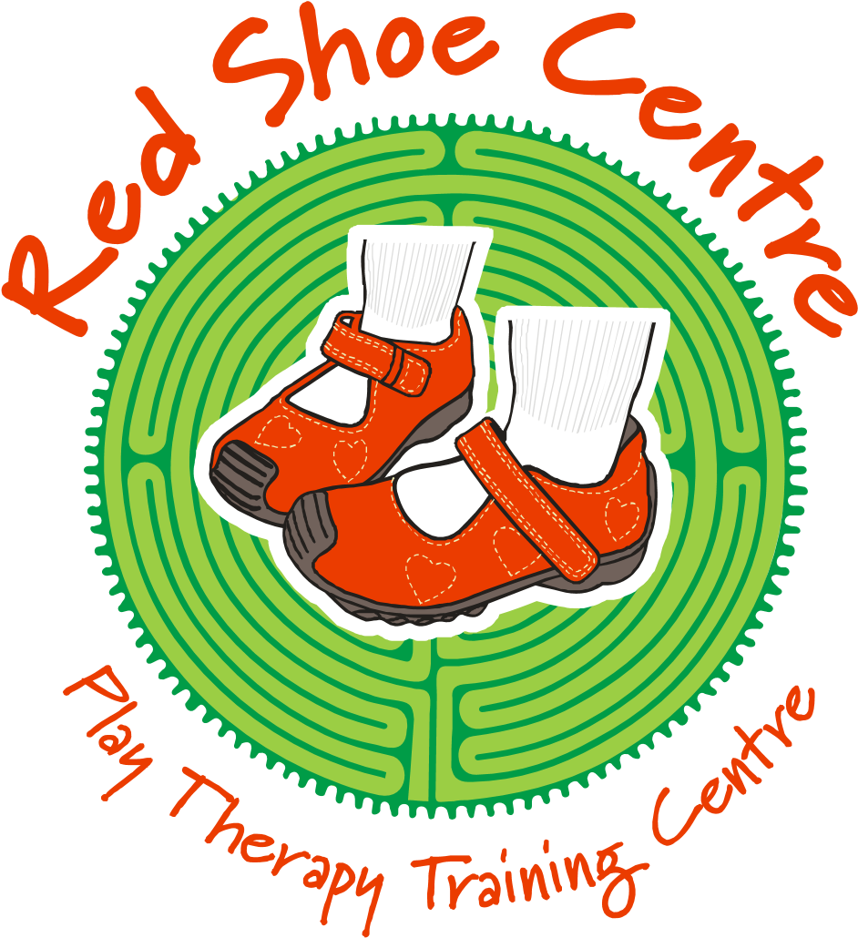

**RED SHOE TRAINING PROGRAMME 2025**

**Red Shoe Training offers exciting workshops in 2025. These workshops can be attended by professionals in the field of child therapy and counseling in South-Africa, such as social workers, psychologists, psychiatrists, occupational therapists, counselors, art therapists and psychiatric nurses, as well as students in these fields. An outline of the contents of each workshop follows. All workshops are presented by Dr Rinda Blom.**

**You are personally invited to embark on a journey of personal and professional growth by attending one or more of the Red Shoe Centre’s workshops during 2025.**

**INTRODUCTION TO PLAY**

**INTERVENTIONS WORKSHOP (ONLINE**

# VIA ZOOM) AFTER HOURS

**Dates:**

**13-18 January 2025**

**24-30 March 2025**

**7-12 July 2025**

**27 October – 1 November 2025**

**ONLINE WORKSHOP TIMES: 18H00-21H00 MONDAY – FRIDAY**

**AND 8H00-16H00 SATURDAY**

**The introduction to play interventions workshop is aimed at providing participants with an introduction to play interventions that can be applied during service-rendering to clients with moderate emotional problems. The following aspects will be addressed:**

* **Unique characteristics of the child client**
* **Theoretical concepts of child-centred play interventions and directive play interventions**
* **A multi-dimensional play interventions model for assessing children**
* **How to prepare for the first session**
* **Setting up a playroom**
* **Goals and administrative forms for the first parent consultation (participants will receive several handouts that can be used)**
* **Assessment play techniques for pre-school children with emotional problems**
* **Assessment play techniques for children 5 years and older**
* **Skills for structuring a non-directive play intervention session** • **Skills for setting boundaries during play interventions**
* **Skills for building a relationships with children in the play room**
* **Understanding children’s unique temperament and how to take this into account when planning a play session**
* **Activities and techniques for enhancing children’s contactmaking skills**
* **Activities and techniques for enhancing children’s self-esteem**
* **Projective techniques that can be applied during play interventions. The focus will be on drawing and painting, clay play, sand tray therapy, dream work and making use of puppets and puppet theatre**
* **Self-nurturing work with children**
* **Termination**

**During the workshop the focus will be on experiential learning and course participants will get the opportunity to use creative media and practice in breakout rooms. DVD clips will be shown to further illustrate certain concepts. Study material will be sent via email.**

**To register, please visit** [**www.playtherapytraining**](http://www.playtherapytraining/) **and book online**

**CPD POINTS: HPCSA level 1 20 CEU’s**

**SACSSP 16.5 CEU’s level 1**

**Course fee: R6500-00**

**Bank details for direct deposits:**

Account name: Red Shoe Training (PTY) LTD

Bank: Standard Bank

Account number: 422216305

Branch code: 055534

Branch: Brandwag

# ADVANCED TRAINING: PLAY INTERVENTIONS WORKSHOP PLAY INTERVENTIONS WORKSHOP

**WITH TRAUMATISED CHILDREN AND**

**CHILDREN WITH ATTACHMENT PROBLEMS (Online via zoom)**

**Presented after hours – workshop times**

**18h00-21h00 Monday – Friday and 8h00-**

# 16h00 Saturday

**Dates:**

**20-25 January 2025**

**14-19 July 2025**

**The advanced play interventions workshop (play interventions with traumatised children and children with attachment problems) is aimed at providing participants with an advanced level of knowledge and skills to integrate different play intervention activities and techniques with specific child client populations with more serious emotional problems/trauma. The following aspects will be addressed:**

* Effect of trauma on children
* Symptoms in traumatized children
* Post-traumatic stress disorder in children
* The psycho-physiology of trauma (effects on the brain stem, limbic system and neocortex)
* Difference between grief and trauma and how to explain this to parents
* Assessment of traumatised children – a multi-dimensional model and specific assessment techniques
* Therapeutic treatment of traumatized children
* Characteristics of post traumatic play in children (how to distinguish between dynamic and stagnant play during play interventions)
* How and when to intervene in repetitive post-traumatic play
* Play intervention techniques for assessing and treating traumatized children (non-directive play interventions and directive play interventions)
* Steps for trauma focused play in children
* Dealing with resistance, transference and counter-transference in play
* Four assessment techniques for assessing families (through drawings, sand play and puppet shows)
* Attachment problems and treating these children
* Play techniques for assessment of parent/child interaction and attachment (how to determine which aspects need to be addressed during developing re-parenting programmes)
* Play techniques for treating attachment disorders in children (how tio implement re-parenting strategies, focusing on challenge, nurture, structure and engagement)
* Parent/child relationship therapy – improving parent/child attachment through play interventions

CPD POINTS:

HPCSA 20 general CEU’s level 1

SACSSP 21 CEU’s level 1

Course material is send via email

Course fee: R7000-00

Bank details for direct deposits:

Account name: Red Shoe Training (PTY) LTD

Bank: Standard Bank

Account number: 422216305

Branch code: 055534

Branch: Brandwag

To register, please visit [www.playtherapytraining.net](http://www.playtherapytraining.net/) and register online

**INTENSIVE SAND TRAY AND APPLIED SAND TRAY INTERVENTION WITH**

**CHILDREN, ADOLESCENTS, FAMILIES AND COUPLES**

**3-7 February 2025**

**21-25 July 2025**

**17-21 November 2025**

## Online workshop times: 18h00-21h00

**This workshop focuses on expanding your professional knowledge and skills of sand tray therapy, as well as applied sand tray therapy. An extensive and integrated workshop in the field of sand tray therapy and applying these skills with children and adults during counselling. The following aspects will be covered:**

* **The structure of the psyche (the unconscious, the conscious, the ego, the persona, the shadow) according to the structure developed by Carl Jung**
* **Examples of how the aspects of the psyche manifest in the sand**
* **Waking up to the unconscious through sand play**
* **Symbolism in sand play -**
* **Significance of the first sand tray**
* **Assessment according to the first tray**
* **A framework for assessment of themes of wouding and themes of transformation in the sand tray**
* **Guidelines for understanding sand tray interventions (in adult and child sand tray work)**
* **How to determine a persona tray**
* **The difference between a wounded tray and a individuation tray**
* **Child development and stages in sand tray therapy – understand during which age wounding took place, as well as what is needed in terms of healing**
* **How self-healing takes place through the sand play process**
* **Archetypes in the sand – miniatures, meanings and how it manifest**
* **Sand tray therapy for bereaved families**
* **Applying sand tray therapy with families where there is a scapegoated child**
* **Individuation sand trays (where family members are enmeshed/ in a symbiotic relationship)**
* **Communication sand trays for families**
* **Amplification in sand work**
* **Trauma trays**
* **Individuation trays for adolescents**
* **Resolving power struggles through sand tray work**
* **Personal sand trays for the therapist (dealing with transference and countertransference issues through sand work)**
* **Using of sand trays for couples therapy (applying the theory of**

**Bowen)**

* + **Stages in sand tray work with couples**
  + **Individuation trays with couples (when to use it, what is consist of, how to conduct it)**
  + **Communication trays (when to use it, what it is, how to conduct it)**
  + **Sand tray to redesign a client’s life situation**
  + **Sand tray techniques for ego-strengthening and skills building**
  + **Sand trays to negotiate opposites**
  + **Family of origin trays**

**,**

**Cost: Online sand tray workshops R5000-00 CPD points:**

**HPCSA 13 general CEU’s**

**SACSSP 11.5 CEU’s**

**Bank details:**

Account name: Red Shoe Training (PTY) LTD

Bank: Standard Bank

Account number: 422216305

Branch code: 055534

Branch: Brandwag

**To register, please visit** [**www.playtherapytraining.net**](http://www.playtherapytraining.net/) **and register online**

# CREATIVE THERAPY WITH TRAUMATISED ADOLESCENTS 2 DAYS INTENSIVE TRAINING

**Dates:**

**20-21 February 2025 (Online via zoom 8h00-16h00)**

**21-22 August 2025 (Online via zoom 8h00-16h00)**

**This workshop is aimed at providing participants with an wealth of creative techniques, as well as a four step therapeutic process that can be applied during therapy with traumatised adolescents. The following aspects will be addressed:**

* Four step therapeutic process during therapeutic work with traumatised adolescents
* Step 1: Understanding the traumatised adolescent’s world (assessment tools and questionnaires)
* Step 2: Building ego-strengh and coping skills through creative activities (activities for setting boundaries, understanding safety and tricky trauma behaviour – learning self-acceptance and self-love)

Step 3: Processing the trauma through expressive creative interventions (telling the story through creative activities)

Step 4: Repair, reframe and moving from victim to thriver (creative interventions for creating a life beyond the trauma)

The workshop will consist of theory and experiential exercises that can be applied to address abovementioned themes. These techniques will be integrated within the theoretical framework of the specific developmental challenges of the adolescent years, as well as special needs in these children as a result of trauma, attachment issues, loss, the quest for identity and increasing the coping strategies of teenagers in difficult circumstances.

**To register, please visit** [**www.playtherapytraining.net**](http://www.playtherapytraining.net/) **and register online**

**Course fee R3800-00 per person**

**CPD points**

**HPCSA 13 General CEU’s level 1**

**SACSSP: 11 CPD POINTS**

Bank details for direct deposits:

Account name: Red Shoe Training (PTY) LTD

Bank: Standard Bank

Account number: 422216305

Branch code: 055534

Branch: Brandwag

# CREATIVE THERAPY WITH TRAUMATISED PRIMARY SCHOOL CHILDREN 2 DAYS INTENSIVE TRAINING

**Dates:**

**13-14 February 2025 (online via zoom 8h00-16H00)**

**15-16 August 2025 (online via zoom 8h00-16h00)**

**This workshop is aimed at providing participants with an wealth of creative techniques, as well as a four step therapeutic process that can be applied during interventions with traumatised primary school children. The following aspects will be addressed:**

* Four step therapeutic process during therapeutic work with traumatised primary school children

Step 1: Understanding the traumatised primary school child’s world (assessment tools and questionnaires)

Step 2: Building ego-strengh and coping skills through creative activities (activities for setting boundaries, understanding safety and tricky trauma behaviour – learning self-acceptance and self-love)

* Step 3: Processing the trauma through expressive creative interventions (telling the story through creative activities)
* Step 4: Repair, reframe and moving from victim to thriver (creative interventions for creating a life beyond the trauma)

The workshop will consist of theory and experiential exercises that can be applied to address abovementioned themes. These techniques will be integrated within the theoretical framework of the specific developmental challenges of the primary school years, as well as special needs in these children as a result of trauma, attachment issues, loss, the quest for identity and increasing the coping strategies of primary school children in difficult circumstances.

**To register, please visit** [**www.playtherapytraining.net**](http://www.playtherapytraining.net/) **and register online**

**Course fee R3800-00 per person**

**CPD points**

**HPCSA 13 general CEU’s level 1**

**SACSSP 11 CEU’s level 1**

Bank details for direct deposits:

Account name: Red Shoe Training (PTY) LTD

Bank: Standard Bank

Account number: 422216305

Branch code: 055534

Branch: Brandwag

**THERAPEUTIC STRATEGIES AND GUIDELINES FOR PARENTAL**

**INVOLVEMENT AND EMPOWERMENT AS**

# PART OF CHILD AND ADOLESCENT THERAPY 2 DAYS INTENSIVE TRAINING

**Dates:**

**Online via zoom 30-31 January 2025**

**Online via zoom 31 July-1 August 2025 Workshop times 8h00-16h00 daily**

This workshop is aimed at providing participants with therapeutic strategies and guidelines for parental involvement and empowerment as part of child and adolescent therapy. The following aspects will be addressed:

* How to design individual therapeutic programmes with high parental involvement

Educating parents through information sheets (handouts that can be used during intervention with parents)

Assisting parents to understand children’s behaviour and have realistic expectations

* Identifying parent’s struggles
* Unfulfilled dependency needs
* A longing to be parented by the child
* A longing to be loved, lack of ability to mentalise
* Need for nurturing
* Marital discord and triangles
* Flight from stress
* Feelings of incompetence
* Self-hate/child-hate
* Punishing rather than prohibiting
* Bonding failure
* Disturbed identity formation
* Cognitive immaturity
* Teaching parents how to take care of themselves in difficult situations or with children with special needs
* Empowering parents to be confident and caring and being able to put children’s needs first
* Teaching parents fun and relationship building activities with children of different ages
* Dealing with parents with special challenges:
  + Dependent parents
  + Aggressive parents
  + Uncooperative parents
  + Parents who are never satisfied
  + Parents with mental health problems
  + Parents of children with chronic

illness

* + Parents under constant stress

The workshop will consist of theory and practical exercises, as well as DVD clips that can be used to address abovementioned aspects. Course participants will receive several handouts that can be copies and used during intervention with parents.

**Course hours 8h00-16h00 daily**

**To register, please visit** [**www.playtherapytraining.net**](http://www.playtherapytraining.net/) **and register online**

**Course fee: R3800-00**

**CPD points**

**HPCSA 14 general CEU’s**

**SACSSP 10 CEU’s level 1**

Bank details for direct deposits:

Account name: Red Shoe Training (PTY) LTD

Bank: Standard Bank

Account number: 422216305

Branch code: 055534

Branch: Brandwag

# ANALYSING STRUCTURE, PROCESS AND DRAWINGS IN CHILDREN’S PLAY

**Dates:**

**Online via zoom 28 February 2025**

**Online via zoom 29 August 2025 Workshop times: 8h00-16h30**

**In this one day refresher workshop, the following will be addressed:**

Ø **The psyche and the art of drawing**

o **Development of children’s drawings**

* **Self-drawings and looking at the drawing of human figures**
* **Drawings of houses and trees**
* **Learning to look at the drawing of a tree**
* **Drawings with a story**
* **Spontaneous drawings**
* **Aggression in drawings**
* **Depression in drawings**
* **Assessment through children’s drawings (the what and how)**
* **Analysing symbols from drawings from the Jungian perspective**
* **The symbolic significance of colours**
* **The symbolic significance of animals**
* **The significance of fantasy figures**
* **Looking systematically at drawings**
* **Handicapped children’s drawings**
* **Family drawings and relationships**
* **Children’s drawings as projective technique; trauma in drawings, drawings of chronically ill children; drawings of sexually abused children**

**To register, please visit** [**www.playtherapytraining.net**](http://www.playtherapytraining.net/) **and register online**

**Course fee R2400-00 CPD points:**

**HPCSA 7 general CEU’s**

**SACSSP 6.5 CPD POINTS**

**Banking details:**

Account name: Red Shoe Training (PTY) LTD

Bank: Standard Bank

Account number: 422216305

Branch code: 055534

Branch: Brandwag

**TREATING COMPLEX TRAUMA IN TEENAGERS (25 HOURS**

**TRAINING)**

**NEW WORKSHOP – NOT TO BE MISSED**

**THIS IS ONE OF THE EXTENSIVE WORKSHOPS ON**

**TREATING COMPLEX TRAUMA IN TEENAGERS THAT IS**

**PRESENTED BY RED SHOE PLAY THERAPY TRAINING**

**CENTRE**

**DATE:**

**2-9 June 2025 Monday-Friday 18h00-21h00, Saturday 8h00-16h00, excluding Sunday**

**CONTENTS**

|  |
| --- |
| What is psychological trauma? |
| What happens in the psyche of the traumatised teenager? |
| Trauma and the brain  The right brain and emotional regulation  The difference between implicit and explicit memories  The brain and body’s emotional stress response  Where does it all start? The relationship between the infant, the caregiver and the emotional right brain The development of resonance between mother and baby  The effect of timing on the relational trauma |
| Attachment styles and complex relational trauma in teenagers  The insecure avoidant attachment style  The insecure ambivalent attachment style  The disorganised attachment style  Secure attachment and earned secure attachment |
| How does dissociation develop?  The structural dissociation model |
| Signs and symptoms of structural dissociated parts Dissociation in teenagers |

|  |
| --- |
| Important principles in the therapeutic process with teenagers and complex trauma  Important aspects of being a trauma-wise therapist  Phases in the therapeutic process |
| **Phase 1: Assessment**  Assessment activities, scales and questionnaires |
| Core dissociative aspects to assess  Important assessment questions to ask  Projective techniques for assessment |
| **Phase 2: Psycho-education**  Important considerations in psycho-education  The language of triggers and triggering  Connecting symptoms to triggers  Common posttraumatic triggers  The therapist as auxiliary cortex  Being a neuro-biological regulator  Activities to use during psycho-education |
| Phase 3: Skills for emotional regulation and strengthening of the ego  Transformative witnessing  Activities for affect regulation  Activities for grounding  Breathing activities  The dissociation kit for teenagers  Skills to stay in the here-and-now and not go there  Pendulation  The calm/safe/happy place  Creating a safe place in the sand |
| **Phase 3: continue**  Imaginary containers  My circle of safe people  Nature as resource  Orienting for hyper- and hypo-arousal  Interoception and bodily awareness  Activities to enhance body awareness  Mindfulness, elements of mindfulness and mindfulness skills  Ways to teach mindfulness skills  Connecting with strengths, inner and outer resources  Self-havening touch  Considerations before moving to phase 4 |
| **Phase 4: Trauma-reprocessing**  Goals in phase 4  Activities for trauma reprocessing  Free journaling  Building boundary awareness  Dual awareness  Working at the edges of affect tolerance  Important considerations in recognising parts and the role they play  Applying grounding skills  The therapist as auxiliary cortex |
| Parts work  Characteristics of parts  Examples of parts  Introducing parts to adolescents  The internal dialogue technique  Mapping parts on the body outline |
| The internal dialogue technique Parts work practical work |
| Parts work practical work |
| Ways to achieve dual awareness  Sand tray directives  Mandala work and parts work |
| The building blocks of internal attachment repair  Negative-positive cognitions  Sand tray work with negative beliefs  How do we know when trauma is processed? |
| Addressing eating disorders, addictions and other self-destructive behaviours in teenagers |
| **Phase 5: Posttraumatic growth**  Aspects to address during this phase  Goals of posttraumatic growth  Resilience practices |
| The tree of life practical exercise |
| Connecting to self-compassion |

**To register, please visit** [**www.playtherapytraining.net**](http://www.playtherapytraining.net/) **and register online**

**Course fee: R7000-00**

**CPD points**

**HPCSA 18 CPD points level 1 and 5 ethical points**

**SACSSP 24 CPD points**

Bank details for direct deposits:

Account name: Red Shoe Training (PTY) LTD

Bank: Standard Bank

Account number: 422216305

Branch code: 055534

Branch: Brandwag

## RED SHOE TRAINING CENTRE

Dr Rinda Blom, director of the Red Shoe Centre, will present all workshops. She is a registered social worker and has extensive theoretical and practical experience in the field of play therapy and psychotherapy with adults. She has a doctoral degree, specializing in the field of play therapy and has lectured a master’s degree in play therapy for eight years at the University of the Free State, where she has guided several students in their clinical play therapy practice, as well as play therapy research projects. Rinda is author of the book: The Handbook of Gestalt Play Therapy: Practical guidelines for child therapists, which was published in London, England during 2006. Dr Violet Oaklander international recognized play therapist, wrote the following about this book: *“This book is one of the most comprehensive treatments I have ever seen about gestalt play therapy. It is a vital and important contribution to the literature of psychotherapy to children.”*

Rinda has 30 year’s play therapy experience in working with children with emotional problems. She also received advanced international training in play therapy and has been training professionals in South-Africa, such as social workers, psychologists and occupational therapists in this field for many years. She has academic honorary colours at two South-African universities and is listed as a top achiever at the Department of Social Work, University of the Free State. She has presented on play therapy related topics at conferences in South-Africa and abroad and has published play therapy related articles in academic journals in South-Africa, as well as internationally.

Disclaimer of liability:

These workshops does not provide the participant with a qualification or professional registration (licencure) in any of the child and adolescent mental health fields. It serves as continuous professional development in the field of child and adolescent mental health